INSTALLING OPENSSL

1. Download the exe in the link the below. Use the highlighted version.

<https://slproweb.com/products/Win32OpenSSL.html>

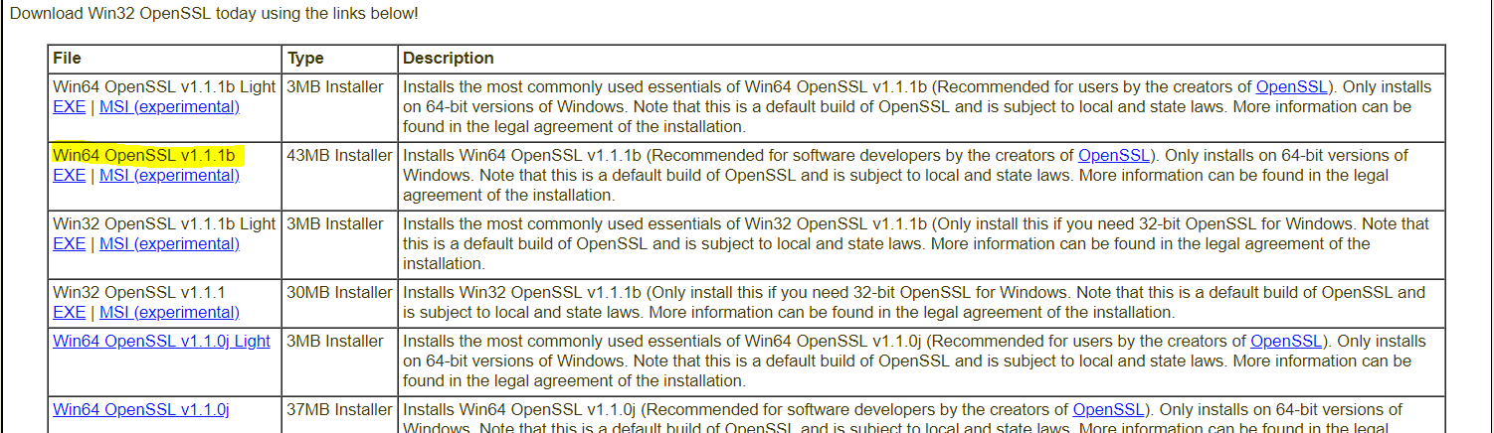

1. On installation the path will be C:\OpenSSL-Win64. However please note that I, Raphael Rodriguez, have installed this into my D: drive. As such please change dependencies in future steps
2. Once installed place the given path in the C/C++ include directories
   1. PATH: C:\OpenSSL-Win64\include

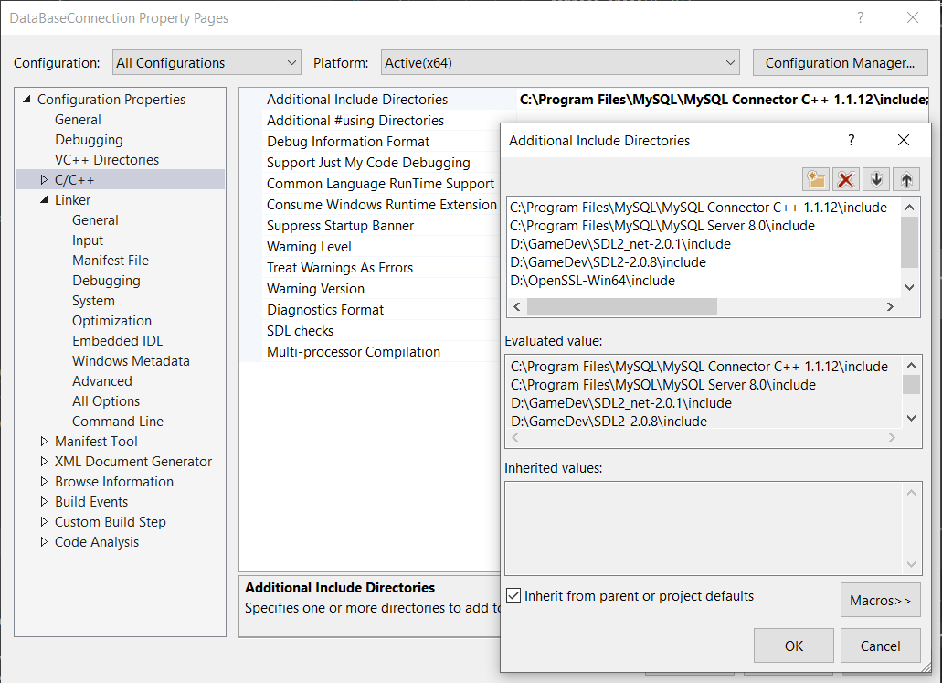

1. Do the same for Linker libraries PATH: C:\OpenSSL-Win64\lib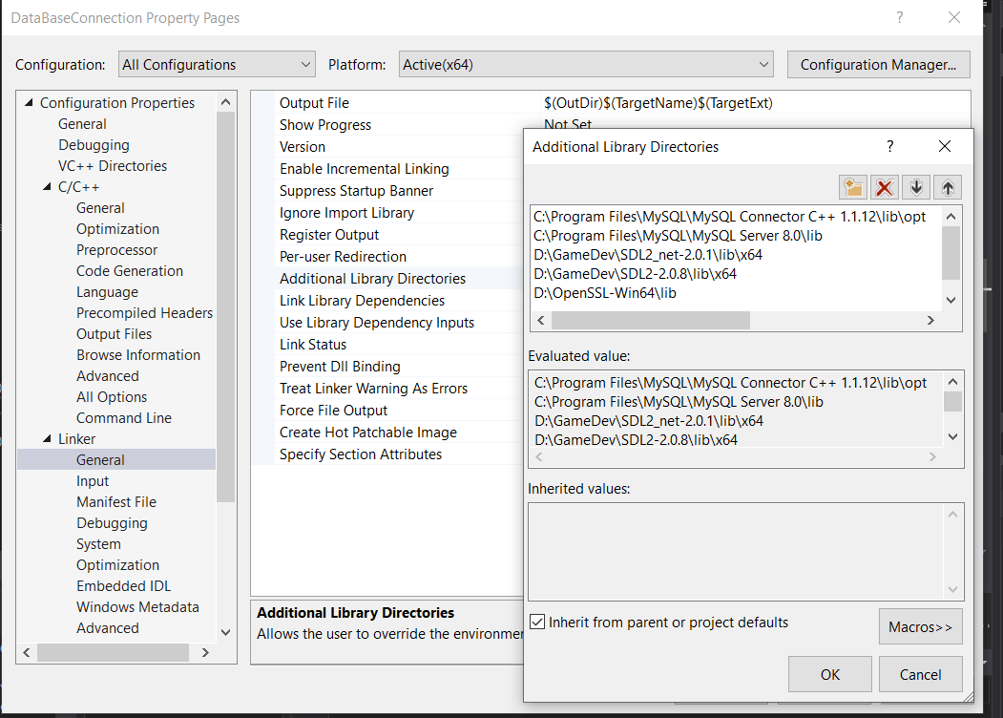
2. Finally include these last file names into linker Input
   1. libssl.lib
   2. libcrypto.lib

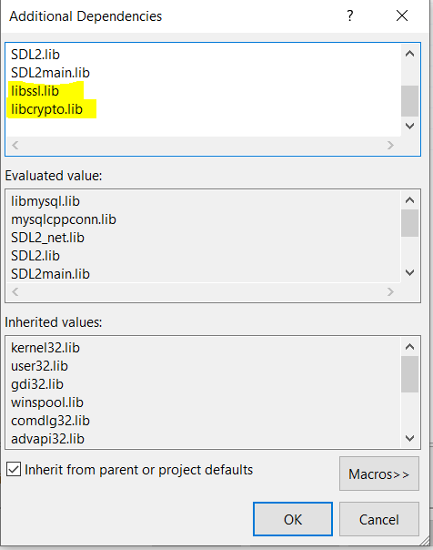

After this is complete OpenSll Should be fully installed and ready for use